Airtame
Official URL: https://services.smsu.edu/TDClient/180/Portal/KB/Article/1060/Airtame
Category: Knowledge Base > Information Technology Services > Software and Applications > Airtame
Tags: airtame
_____________________________________________________

Airtame Wireless Screen Sharing
Airtame is a wireless screen‑sharing device that allows you to display content from your personal or SMSU‑issued device onto a TV or display screen. By installing the Airtame application, users can share their screen without needing cables or adapters.
Airtame is available in the following locations:
- Library
- Computer Lab
This service supports a wide range of devices, making it easy to present, collaborate, or share content in campus spaces.
Use the following resource to get started:
Airtame setup and connection instructions ​​​​​​
_____________________________________________________

Airtame Setup & Connection Instructions (PDF Guide)
Attached Resource Info: Scraped and inlined from the official PDF attachment: Airtame Wireless Display Setup
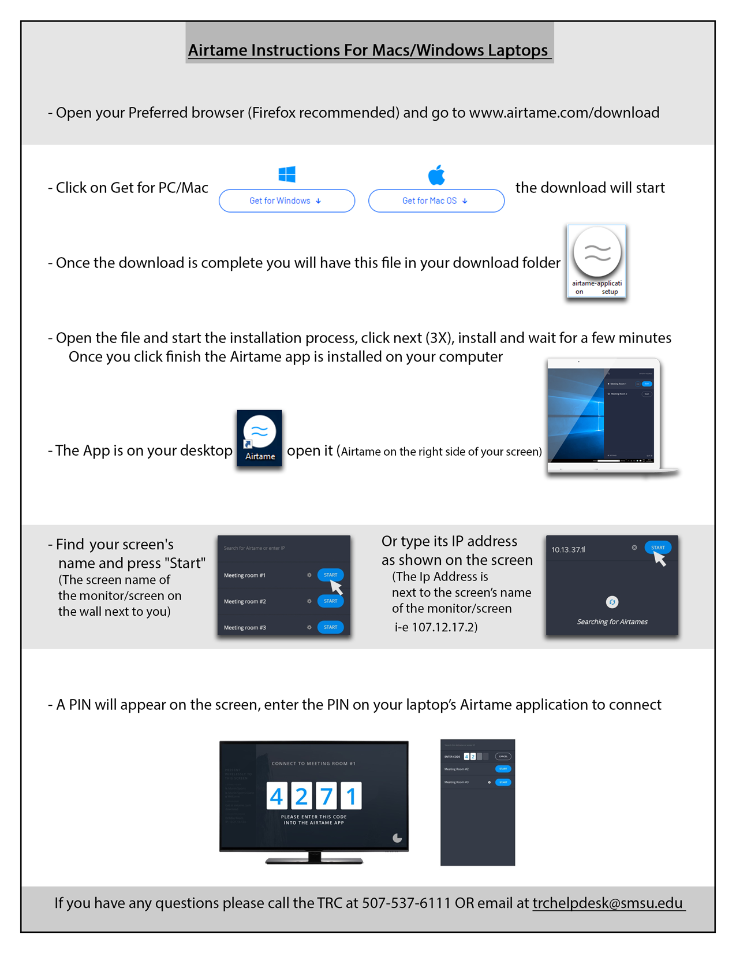
Figure 1 (PDF Attachment Page 1): Scanned setup guide sheet from 'Airtame Setup & Connection Instructions (PDF Guide)'
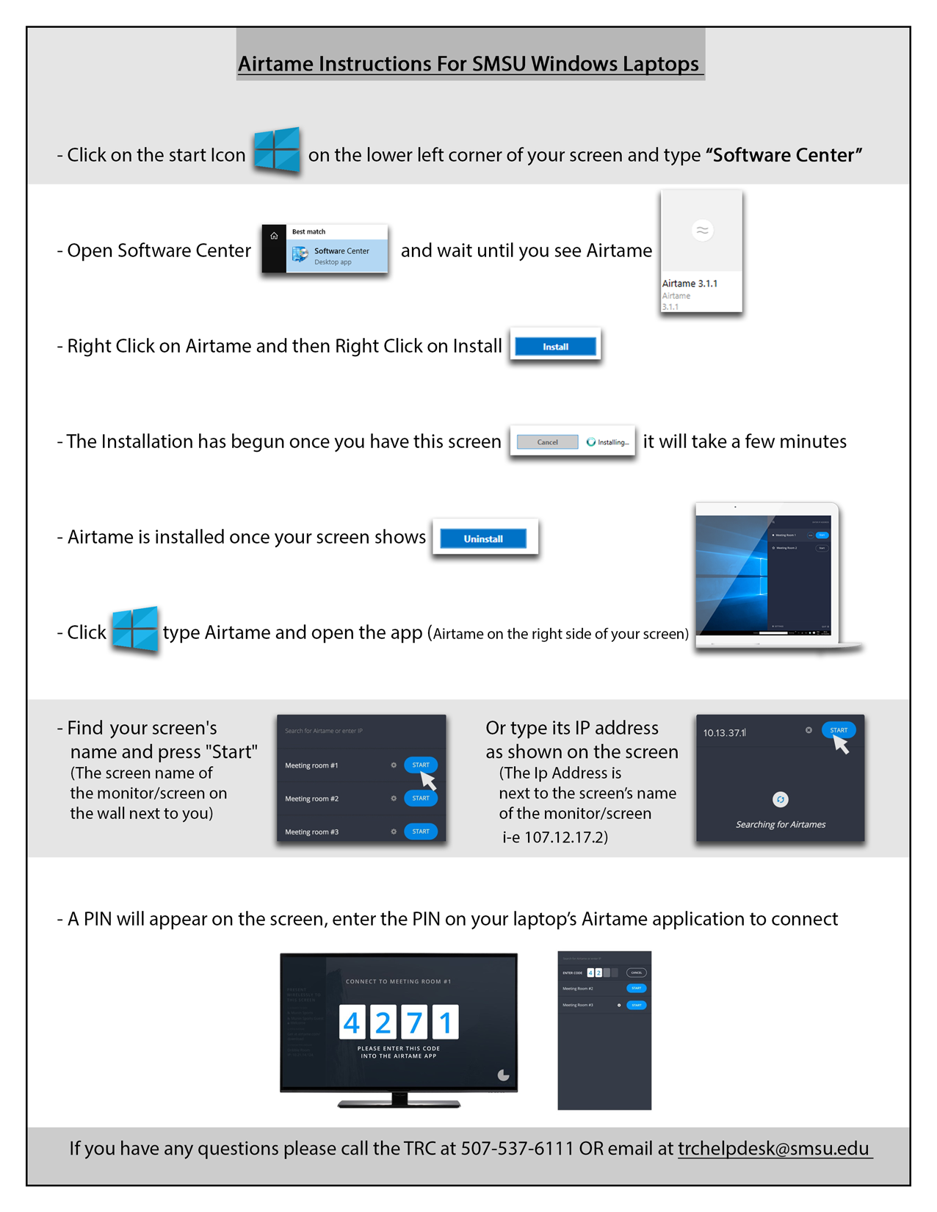
Figure 2 (PDF Attachment Page 2): Scanned setup guide sheet from 'Airtame Setup & Connection Instructions (PDF Guide)'
Accessibility Review & Update Log:
- [x] Content accuracy and link integrity verified
- [x] High-contrast visual hierarchy implemented (Inter and Calibri)
- [x] Image alt-text captions verified (all screenshots captioned)
- [x] PDF attachments scraped and fully inlined directly inside the document
- [x] Outline headers and standard list sequences optimized for screen readers

